

Machine Learning Lab Manual
Navkis College of Engineering, Hassan
(An Initiative from Sri M. S Ramaiah)
Affiliated to VTU, Recognized by Govt. of Karnataka, Approved by AICTE KIADB Thimmanahalli Industrial Area, NH-75, Kandali-573217,
Hassan, Karnataka. Tel: 08172-297464 | Email: aid@navkisce.ac.in
BCSL606
Academic Year: 2025-26
Dept. of AI&DS, As Per VTU Syllabus

Prepared By

Prof. Vidya H A
Department of AI&DS, NCE HASSAN

Reviewed By Dr. Vinutha M R Professor and Head
Department of AI&DS, NCE HASSAN

Navkis College of Engineering Hassan
KIADB Thimmanahalli Industrial Area, NH-75, Kandali-573217, Hassan, Karnataka



Department of Artificial Intelligence & Data Science

Lab Manual

MACHINE LEARNING LAB

BCSL606

VI Semester

Academic Year 2025-26
Version-1

Name:

USN:

Batch: Section:

Prepared by
Department of Artificial Intelligence & Data Science
Navkis College of Engineering Hassan
Affiliated to VTU, Recognized by Govt. of Karnataka, Approved by AICTE
KIADB Thimmanahalli Industrial Area, NH-75, Kandali-573217, Hassan,
Karnataka
Tel: 08172-297464 | Email: aid@navkisce.ac.in


NAVKIS COLLEGE OF ENGINEERING HASSAN
(An Initiative from Sri M. S Ramaiah)
Affiliated to VTU, Recognized by Govt. of Karnataka, Approved by AICTE KIADB Thimmanahalli Industrial Area, NH-75, Kandali-573217,
Hassan, Karnataka. Tel: 08172-297464|Email: aid@navkisce.ac.in

VISION OF THE INSTITUTE
“To be an illustrious institution imparting quality engineering education and prepare globally accredited and socially responsible professionals”

MISSION OF THE INSTITUTE
M1: To provide state-of-the-art facilities for quality education and research M2: To interact with industries and institutions of higher learning
M3: To facilitate research activities and promote entrepreneurship

M4: To nurture ethics and responsible citizenship

VISION OF THE DEPARTMENT
“To Become a Prominent Education and Research Center Producing Globally Competent Engineers in Artificial Intelligence and Data Science”

MISSION OF THE DEPARTMENT
M1: To Provide State-of-the-art Facilities for Education and Research M2: To Interact with Industries and Institutions of Higher Learning M3: To Facilitate Research Activities and Promote Entrepreneurship M4: To Nurture Ethics and Responsible Citizenship

PROGRAM EDUCATIONAL OBJECTIVES
PEO1: Serve as successful Artificial Intelligence engineers or data scientists Professionals.
PEO2: Pursue Higher Learning and or Take up Business.

PEO3: Exhibit honourable professionalism and social responsibility.

PROGRAM SPECIFIC OBJECTIVES
PSO1: Analyze and design solutions to real world problems using the knowledge of Artificial Intelligence and Data Science.
PSO2: Build Intelligent systems using appropriate hardware/software tools and techniques.

COURSE OBJECTIVES
- To become familiar with data and visualize univariate, bivariate, and multivariate data using statistical techniques and dimensionality reduction.

- To understand various machine learning algorithms such as similarity-based learning, regression, decision trees, and clustering.
- To familiarize with learning theories, probability-based models and developing the skills required for decision-making in dynamic environments.

COURSE OUTCOMES
CO1: Illustrate the principles of multivariate data and apply dimensionality reduction techniques
CO2: Demonstrate similarity-based learning methods and perform regression analysis

CO3: Develop decision trees for classification and regression problems, and Bayesian models for probabilistic learning

CO4: Implement the clustering algorithms to share computing resources

PROGRAM OUTCOMES
- Engineering knowledge: Apply the knowledge of mathematics, science, engineering fundamentals, and an engineering specialization for the solution of complex engineering problems.
- Problem analysis: Identify, formulate, research literature, and analyze complex engineering problems reaching substantiated conclusions using first principles of mathematics, natural sciences, and engineering sciences.
- Design/development of solutions: Design solutions for complex engineering problems and design system components or processes that meet the specified needs.
- Conduct investigations of complex problems: An ability to design and conduct scientific and engineering experiments, as well as to analyze and interpret data to provide valid conclusions
- Modern tool usage: Ability to apply appropriate techniques, modern engineering and IT tools, to engineering problems.
- The engineer and society: An ability to apply reasoning to assess societal, safety, health and cultural issues and the consequent responsibilities relevant to the professional engineering practice
- Environment and sustainability: An ability to understand the impact of professional engineering solutions in societal and environmental contexts
- Ethics: Apply ethical principles and commit to professional ethics and responsibilities and norms of the engineering practice.
- Individual and team work: Ability to function effectively as an individual, and as a member or leader in a team, and in multidisciplinary tasks.
- Communication: Ability to communicate effectively on engineering activities with the engineering community such as, being able to comprehend and write effective reports and design documentation, make effective presentations.
- Project management and finance: An ability to apply knowledge, skills, tools, and techniques to project activities to meet the project requirements with the aim of managing project resources properly and achieving the project’s objectives.
- Life-long learning: Recognize the need for, and have the preparation and ability to engage
in independent and life-long learning in the broadest context of technological change.

Machine Learning lab |  |  | Semester | 6
Course Code |  | BCSL606 | CIE Marks | 50
Teaching Hours/Week (L:T:P: S) |  | 0:0:2:0 | SEE Marks | 50
Credits |  | 01 | Exam Hours | 100
Examination type (SEE) |  | Practical
Course objectives:
- To become familiar with data and visualize univariate, bivariate, and multivariate data using statistical techniques and dimensionality reduction.
- To understand various machine learning algorithms such as similarity-based learning, regression, decision trees, and clustering.
- To familiarize with learning theories, probability-based models and developing the skills required for
decision-making in dynamic environments.
Sl.NO | Experiments
1 | Develop a program to create histograms for all numerical features and analyze the distribution of each feature. Generate box plots for all numerical features and identify any outliers. Use California Housing dataset.  Book 1: Chapter 2
2 | Develop a program to Compute the correlation matrix to understand the relationships between pairs of features. Visualize the correlation matrix using a heatmap to know which variables have strong positive/negative correlations. Create a pair plot to visualize pairwise relationships between features. Use California Housing dataset.  Book 1: Chapter 2
3 | Develop a program to implement Principal Component Analysis (PCA) for reducing the dimensionality of the Iris dataset from 4 features to 2.  Book 1: Chapter 2
4 | For a given set of training data examples stored in a .CSV file, implement and demonstrate the Find-S algorithm to output a description of the set of all hypotheses consistent with the training examples.  Book 1: Chapter 3
5 | Develop a program to implement k-Nearest Neighbour algorithm to classify the randomly generated 100 values of x in the range of [0,1]. Perform the following based on dataset generated.  - Label the first 50 points {x1,……,x50} as follows: if (xi ≤ 0.5), then xi ∊ Class1, else xi ∊ Class1  - Classify the remaining points, x51,……,x100 using KNN. Perform this for k=1,2,3,4,5,20,30  Book 2: Chapter – 2
6 | Implement the non-parametric Locally Weighted Regression algorithm in order to fit data points. Select appropriate data set for your experiment and draw graphs  Book 1: Chapter – 4
7 | Develop a program to demonstrate the working of Linear Regression and Polynomial Regression. Use Boston Housing Dataset for Linear Regression and Auto MPG Dataset (for vehicle fuel efficiency prediction) for Polynomial Regression.  Book 1: Chapter – 5
8 | Develop a program to demonstrate the working of the decision tree algorithm. Use Breast Cancer Data set for building the decision tree and apply this knowledge to classify a new sample.  Book 2: Chapter – 3

9 | Develop a program to implement the Naive Bayesian classifier considering Olivetti Face Data set for training. Compute the accuracy of the classifier, considering a few test data sets.  Book 2: Chapter – 4
10 | Develop a program to implement k-means clustering using Wisconsin Breast Cancer data set and visualize the clustering result.  Book 2: Chapter – 4
Course outcomes (Course Skill Set):
At the end of the course the student will be able to:
- Illustrate the principles of multivariate data and apply dimensionality reduction techniques.
- Demonstrate similarity-based learning methods and perform regression analysis.
- Develop decision trees for classification and regression problems, and Bayesian models for probabilistic learning.
- Implement the clustering algorithms to share computing resources.
Assessment Details (both CIE and SEE)
The weightage of Continuous Internal Evaluation (CIE) is 50% and for Semester End Exam (SEE) is 50%. The minimum passing mark for the CIE is 40% of the maximum marks (20 marks out of 50) and for the SEE minimum passing mark is 35% of the maximum marks (18 out of 50 marks). A student shall be deemed to have satisfied the academic requirements and earned the credits allotted to each subject/ course if the student secures a minimum of 40% (40 marks out of 100) in the sum total of the CIE (Continuous Internal Evaluation) and SEE (Semester End Examination) taken together

Continuous Internal Evaluation (CIE):
CIE marks for the practical course are 50 Marks.
The split-up of CIE marks for record/ journal and test are in the ratio 60:40.
- Each experiment is to be evaluated for conduction with an observation sheet and record write-up. Rubrics for the evaluation of the journal/write-up for hardware/software experiments are designed by the faculty who is handling the laboratory session and are made known to students at the beginning of the practical session.
- Record should contain all the specified experiments in the syllabus and each experiment write-up will be evaluated for 10 marks.
- Total marks scored by the students are scaled down to 30 marks (60% of maximum marks).
- Weightage to be given for neatness and submission of record/write-up on time.
- Department shall conduct a test of 100 marks after the completion of all the experiments listed in the syllabus.
- In a test, test write-up, conduction of experiment, acceptable result, and procedural knowledge will carry a weightage of 60% and the rest 40% for viva-voce.
- The suitable rubrics can be designed to evaluate each student’s performance and learning ability.
- The marks scored shall be scaled down to 20 marks (40% of the maximum marks).
The Sum of scaled-down marks scored in the report write-up/journal and marks of a test is the total CIE marks scored by the student.

Semester End Evaluation (SEE):
- SEE marks for the practical course are 50 Marks.
- SEE shall be conducted jointly by the two examiners of the same institute, examiners are appointed by the Head of the Institute.
- The examination schedule and names of examiners are informed to the university before the conduction of the examination. These practical examinations are to be conducted between the schedule mentioned in the academic calendar of the University.
- All laboratory experiments are to be included for practical examination.
- (Rubrics) Breakup of marks and the instructions printed on the cover page of the answer script to be strictly adhered to by the examiners. OR based on the course requirement evaluation rubrics shall be decided jointly by examiners.
- Students can pick one question (experiment) from the questions lot prepared by the examiners jointly.
- Evaluation of test write-up/ conduction procedure and result/viva will be conducted jointly by examiners.
General rubrics suggested for SEE are mentioned here, writeup-20%, Conduction procedure and result in -60%, Viva-voce 20% of maximum marks. SEE for practical shall be evaluated for 100 marks and scored marks shall be scaled down to 50 marks (however, based on course type, rubrics shall be decided by the examiners)
Change of experiment is allowed only once and 15% of Marks allotted to the procedure part are to be made zero.
The minimum duration of SEE is 02 hours
Suggested Learning Resources:
Books:
- S Sridhar and M Vijayalakshmi, “Machine Learning”, Oxford University Press, 2021.
- M N Murty and Ananthanarayana V S, “Machine Learning: Theory and Practice”, Universities Press (India) Pvt. Limited, 2024.

Web links and Video Lectures (e-Resources):
  - https://www.drssridhar.com/?page_id=1053
  - https://www.universitiespress.com/resources?id=9789393330697
  - https://onlinecourses.nptel.ac.in/noc23_cs18/preview

CONTENTS

PROGRAM  NO. | PROGRAM TITLE | PAGE NO.
1 | Develop a program to create histograms for all numerical features and analyze the distribution of each feature. Generate box plots for all numerical features and identify any outliers. Use California  Housing dataset. | 1-2
2 | Develop a program to Compute the correlation matrix to understand the relationships between pairs of features. Visualize the correlation matrix using a heatmap to know which variables have strong positive/negative correlations. Create a pair plot to  visualize pairwise relationships between features. Use California Housing dataset. | 3-5
3 | Develop a program to implement Principal Component Analysis  (PCA) for reducing the dimensionality of the Iris dataset from 4 features to 2. | 6
4 | For a given set of training data examples stored in a .CSV file, implement and demonstrate the Find-S algorithm to output a description of the set of all hypotheses consistent with the training  examples. | 7
5 | Develop a program to implement k-Nearest Neighbour algorithm to classify the randomly generated 100 values of x in the range of [0,1]. Perform the following based on dataset generated.  - Label the first 50 points {x1,……,x50} as follows: if (xi ≤ 0.5), then xi ε Class1, else xi ε Class1  - Classify the remaining points, x51,……,x100 using KNN. Perform this for k=1,2,3,4,5,20,30 | 8-9
6 | Implement the non-parametric Locally Weighted Regression algorithm in order to fit data points. Select appropriate data set for  your experiment and draw graphs | 10-11
7 | Develop a program to demonstrate the working of Linear Regression and Polynomial Regression. Use Boston Housing Dataset for Linear Regression and Auto MPG Dataset (for vehicle  fuel efficiency prediction) for Polynomial Regression. | 12-14
8 | Develop a program to demonstrate the working of the decision tree  algorithm. Use Breast Cancer Data set for building the decision tree and apply this knowledge to classify a new sample. | 15-16
9 | Develop a program to implement the Naive Bayesian classifier considering Olivetti Face Data set for training. Compute the  accuracy of the classifier, considering a few test data sets. | 17
10 | Develop a program to implement k-means clustering using  Wisconsin Breast Cancer data set and visualize the clustering result. | 18
11 | Viva Questions | 19-22

- Develop a program to create histograms for all numerical features and analyze the distribution of each feature. Generate box plots for all numerical features and identify any outliers. Use California Housing dataset.
import matplotlib.pyplot as plt import seaborn as sns
import pandas as pd
from sklearn.datasets import fetch_california_housing

# Load California Housing dataset data = fetch_california_housing()
df = pd.DataFrame(data.data, columns=data.feature_names)

# Print dataset feature names and first 5 rows print("Dataset Features:", list(df.columns)) print("\nFirst 5 Rows of the Dataset:") print(df.head())

# Create histograms for all numerical features plt.figure(figsize=(12, 8))
df.hist(bins=30, figsize=(12, 8), color='skyblue', edgecolor='black') plt.suptitle("Histograms of Numerical Features in California Housing Dataset", fontsize=14)
plt.show()

# Generate box plots to identify outliers plt.figure(figsize=(12, 8))
for i, column in enumerate(df.columns, 1): plt.subplot(2, 4, i) sns.boxplot(y=df[column], color='lightblue') plt.title(column)
plt.suptitle("Box Plots of Numerical Features in California Housing Dataset", fontsize=14)
plt.tight_layout()
plt.show()

Output:
Dataset Features: ['MedInc', 'HouseAge', 'AveRooms', 'AveBedrms', 'Population', 'AveOccup', 'Latitude', 'Longitude']
First 5 Rows of the Dataset:
MedInc HouseAge AveRooms AveBedrms Population AveOccup Latitude Longitude

0 8.3252 | 41.0 | 6.984127 | 1.023810 | 322.0 | 2.555556 | 37.88 | -122.23
1 8.3014 | 21.0 | 6.238137 | 0.971880 | 2401.0 | 2.109842 | 37.86 | -122.22
2 7.2574 | 52.0 | 8.288136 | 1.073446 | 496.0 | 2.802260 | 37.85 | -122.23
3 5.6431 | 52.0 | 5.817352 | 1.073059 | 558.0 | 2.547945 | 37.85 | -122.24
4 3.8462 | 52.0 | 6.281853 | 1.081081 | 565.0 | 2.181467 | 37.85 | -122.25

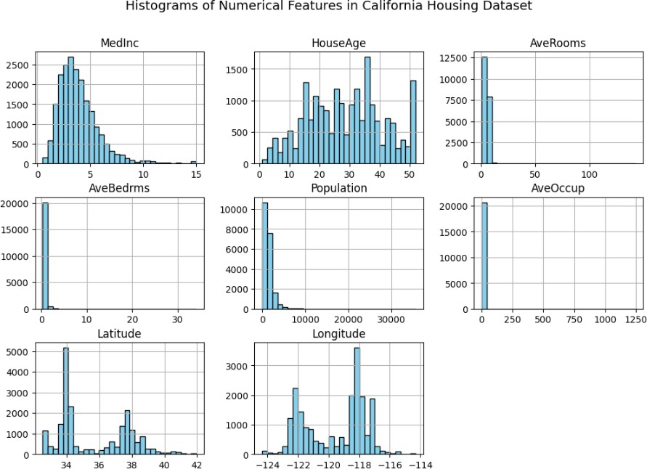
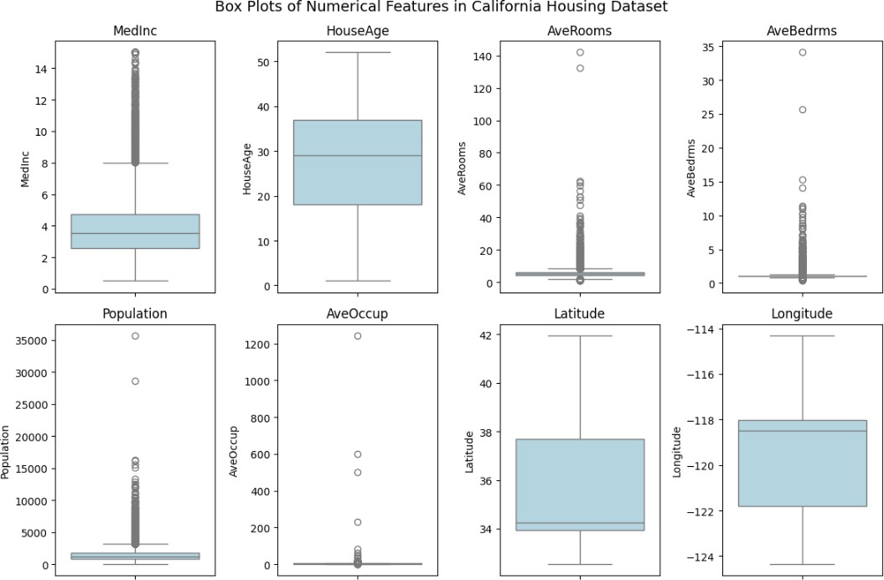

- Develop a program to compute the correlation matrix to understand the relationships between pairs of features. Visualize the correlation matrix using a heatmap to know which variables have strong positive/negative correlations. Create a pair plot to visualize pairwise relationships between features. Use California Housing dataset.
import matplotlib.pyplot as plt

import seaborn as sns import pandas as pd
from sklearn.datasets import fetch_california_housing

# Load California Housing dataset data = fetch_california_housing()
df = pd.DataFrame(data.data, columns=data.feature_names)

# Print dataset feature names and first 5 rows print("Dataset Features:", list(df.columns)) print("\nFirst 5 Rows of the Dataset:") print(df.head())

# Compute and visualize correlation matrix correlation_matrix = df.corr() plt.figure(figsize=(10, 8))
sns.heatmap(correlation_matrix, annot=True, cmap='coolwarm', fmt='.2f', linewidths=0.5)
plt.title("Correlation Matrix of California Housing Dataset") plt.show()

# Create a pair plot to visualize pairwise relationships between features sns.pairplot(df, diag_kind='kde', plot_kws={'alpha':0.5}) plt.suptitle("Pair Plot of California Housing Dataset", fontsize=14) plt.show()

# Create histograms for all numerical features plt.figure(figsize=(12, 8))
df.hist(bins=30, figsize=(12, 8), color='skyblue', edgecolor='black') plt.suptitle("Histograms of Numerical Features in California Housing Dataset", fontsize=14)
plt.show()

# Generate box plots to identify outliers plt.figure(figsize=(12, 8))
for i, column in enumerate(df.columns, 1): plt.subplot(2, 4, i) sns.boxplot(y=df[column], color='lightblue') plt.title(column)
plt.suptitle("Box Plots of Numerical Features in California Housing Dataset", fontsize=14)
plt.tight_layout() plt.show()

Output :

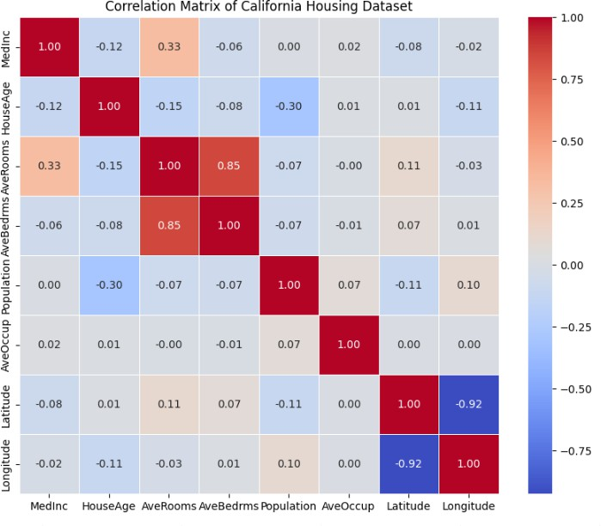

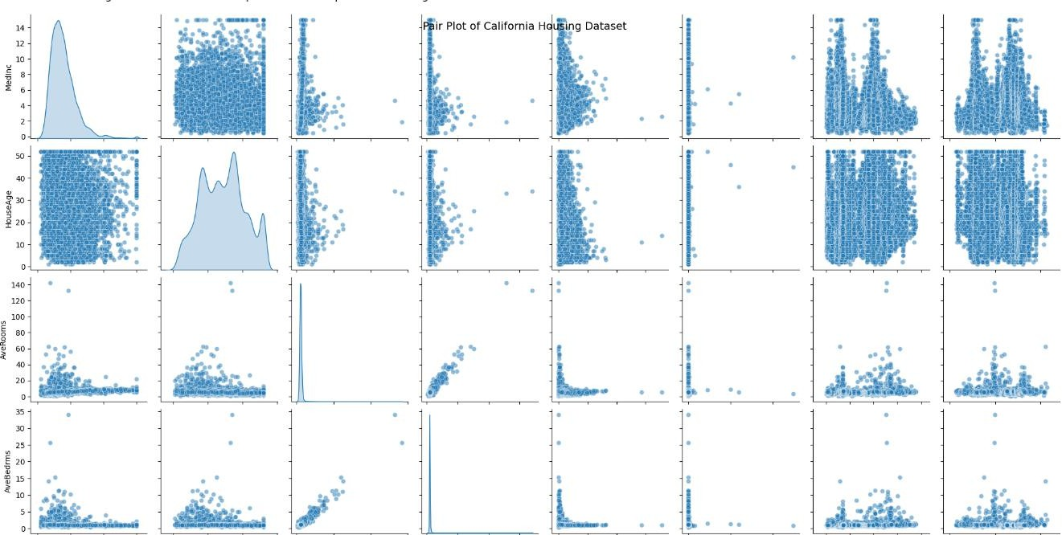

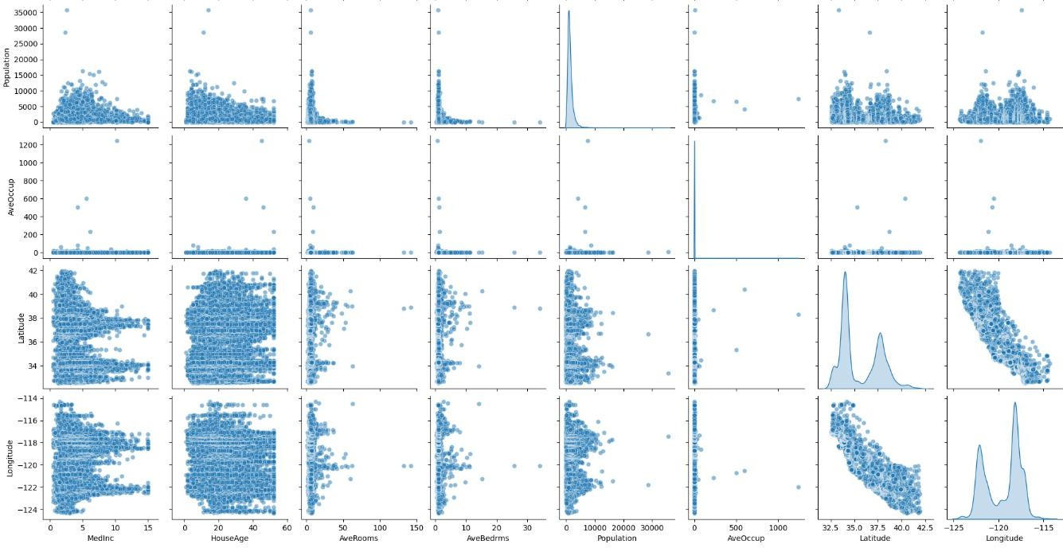

- Develop a program to implement Principal Component Analysis (PCA) for reducing the dimensionality of the Iris dataset from 4 features to 2.
import numpy as np
import matplotlib.pyplot as plt import seaborn as sns
import pandas as pd
from sklearn.decomposition import PCA from sklearn.datasets import load_iris
from sklearn.preprocessing import StandardScaler

# Load Iris dataset data = load_iris()
df = pd.DataFrame(data.data, columns=data.feature_names)

# Standardize the dataset scaler = StandardScaler()
df_scaled = scaler.fit_transform(df)

# Apply PCA to reduce dimensionality from 4 to 2 pca = PCA(n_components=2)
principal_components = pca.fit_transform(df_scaled)

# Create a DataFrame with the principal components
pca_df = pd.DataFrame(principal_components, columns=['PC1', 'PC2']) pca_df['Target'] = data.target

# Visualize the PCA results plt.figure(figsize=(8, 6))
sns.scatterplot(x='PC1', y='PC2', hue=pca_df['Target'], palette='Set1', data=pca_df)
plt.title('PCA of Iris Dataset (2 Components)') plt.xlabel('Principal Component 1')
plt.ylabel('Principal Component 2') plt.legend(title='Target') plt.show()
Output :
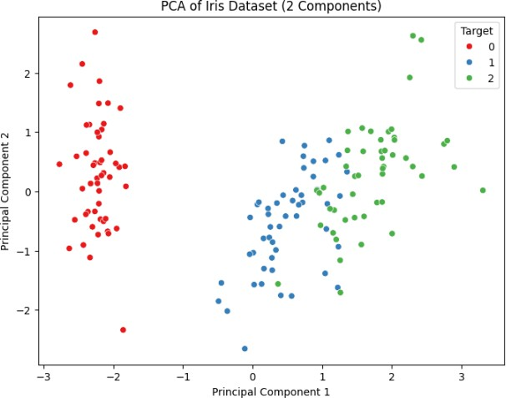

- For a given set of training data examples stored in a .CSV file, implement and demonstrate the Find-S algorithm to output a description of the set of all hypotheses consistent with the training examples.

Example CSV File (training_data.csv)

Here's an example dataset with attributes:

Sky | Temperature | Humidity | Wind | Water | Forecast | EnjoySport
Sunny | Warm | Normal | Strong | Warm | Same | Yes
Sunny | Warm | High | Strong | Warm | Same | Yes
Rainy | Cold | High | Strong | Warm | Change | No
Sunny | Warm | High | Strong | Cool | Change | Yes

Save this data as training_data.csv.
import pandas as pd import numpy as np

# Load the CSV file
data = pd.read_csv("training_data.csv")

# Extract features (X) and target variable (y)
X = data.iloc[:, :-1] # All columns except the last one y = data.iloc[:, -1] # Last column (EnjoySport)

# Find-S Algorithm Implementation def find_s(X, y):
# Initialize hypothesis to the first positive example hypothesis = None

for i in range(len(y)):
if y[i] == "Yes": # Consider only positive examples if hypothesis is None:
hypothesis = X.iloc[i].values # First positive example else:
# Generalize hypothesis
for j in range(len(hypothesis)):
if hypothesis[j] != X.iloc[i, j]: hypothesis[j] = "?" # Generalize
return hypothesis # Run Find-S Algorithm
hypothesis = find_s(X, y)

# Print the output hypothesis print("Final Hypothesis:", hypothesis)
Output :

Final Hypothesis: ['Sunny' 'Warm' '?' 'Strong' '?' '?']

- Develop a program to implement k-Nearest Neighbour algorithm to classify the randomly generated 100 values of x in the range of [0,1]. Perform the following based on dataset generated. a. Label the first 50 points {x1, ,x50} as follows: if (xi ≤ 0.5), then xi ∊ Class1,
else xi ∊ Class1
b. Classify the remaining points, x51,......,x100 using KNN. Perform this for k=1,2,3,4,5,20,30.
import numpy as np
import matplotlib.pyplot as plt
from sklearn.neighbors import KNeighborsClassifier from sklearn.metrics import accuracy_score

# Step 1: Generate 100 random points in the range [0,1] np.random.seed(42) # For reproducibility
X = np.random.rand(100, 1)

# Step 2: Label the first 50 points y = np.zeros(100)
y[:50] = 1 # Label Class 1 for the first 50 points (xi <= 0.5) y[50:] = 2 # Label Class 2 for the remaining points (xi > 0.5)

# Step 3: Split the data into training and testing sets X_train = X[:50] # First 50 points as training data
y_train = y[:50] # Corresponding labels for the first 50 points X_test = X[50:] # Remaining points as testing data
y_test = y[50:] # Corresponding labels for the remaining points

# Step 4: Classify the test set using KNN for different values of k k_values = [1, 2, 3, 4, 5, 20, 30]
accuracy_results = []

for k in k_values:
knn = KNeighborsClassifier(n_neighbors=k) knn.fit(X_train, y_train)

# Make predictions for the test set y_pred = knn.predict(X_test)

# Calculate the accuracy of the model accuracy = accuracy_score(y_test, y_pred) accuracy_results.append(accuracy)

print(f"Accuracy for k={k}: {accuracy:.4f}")

# Step 5: Visualize the results plt.figure(figsize=(10, 6))

for k, accuracy in zip(k_values, accuracy_results):
plt.plot(k, accuracy, 'o', label=f'k={k} (Acc={accuracy:.2f})')

plt.title('KNN Classifier Accuracy for Different k Values') plt.xlabel('k')
plt.ylabel('Accuracy') plt.legend() plt.grid(True)
plt.show()

Output :

Accuracy for k=1: 0.0000 Accuracy for k=2: 0.0000 Accuracy for k=3: 0.0000 Accuracy for k=4: 0.0000 Accuracy for k=5: 0.0000 Accuracy for k=20: 0.0000 Accuracy for k=30: 0.0000

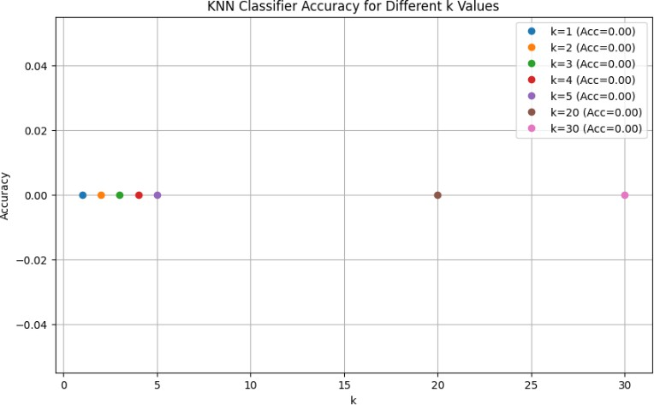

- Implement the non-parametric Locally Weighted Regression algorithm in order to fit data points. Select appropriate data set for your experiment and draw graphs.
import numpy as np
import matplotlib.pyplot as plt

# Step 1: Generate dataset (sinusoidal with noise) np.random.seed(42) # For reproducibility
X = np.sort(np.random.rand(100, 1) * 10, axis=0) # Random x values between 0 and 10
y = np.sin(X) + 0.1 * np.random.randn(100, 1) # y = sin(x) with noise

# Step 2: Implement Locally Weighted Regression (LWR)
def locally_weighted_regression(X_train, y_train, x_query, tau=1.0): m, n = X_train.shape
weights = np.zeros((m, m))

# Create the weight matrix for i in range(m):
diff = x_query - X_train[i]
weights[i, i] = np.exp(-np.sum(diff ** 2) / (2 * tau ** 2)) # Gaussian
kernel

# Compute theta using the weighted least squares method
X_transpose = np.hstack([np.ones((m, 1)), X_train]) # Add bias term (1)
X_transpose_T = X_transpose.T
theta = np.linalg.inv(X_transpose_T @ (weights @ X_transpose)) @ (X_transpose_T @ (weights @ y_train))

return theta[0] + theta[1] * x_query # Return the prediction for the query point

# Step 3: Fit LWR for each point in the range and plot the results tau = 1.0 # Bandwidth parameter
X_query = np.linspace(0, 10, 200).reshape(-1, 1) # Query points for prediction y_pred = np.zeros_like(X_query)

for i, x in enumerate(X_query):
y_pred[i] = locally_weighted_regression(X, y, x, tau)

# Step 4: Visualize the results plt.figure(figsize=(10, 6))
plt.scatter(X, y, color='blue', label='Noisy data', alpha=0.7) plt.plot(X_query, y_pred, color='red', label='LWR fit') plt.title("Locally Weighted Regression (LWR) Fit") plt.xlabel('X')
plt.ylabel('y') plt.legend() plt.grid(True)
plt.show()

Output :
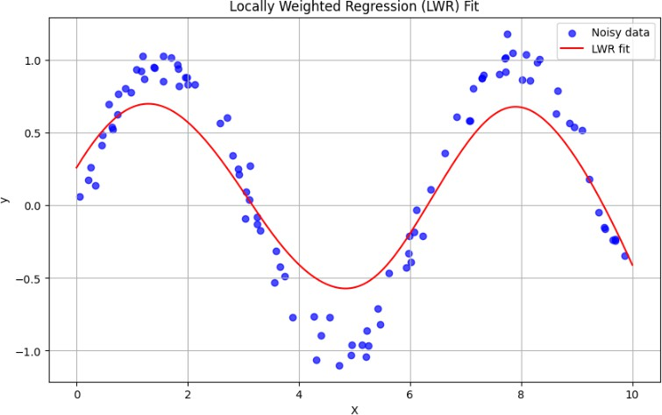

- Develop a program to demonstrate the working of Linear Regression and Polynomial Regression. Use Boston Housing Dataset for Linear Regression and Auto MPG Dataset (for vehicle fuel efficiency prediction) for Polynomial Regression.

import numpy as np import pandas as pd
import matplotlib.pyplot as plt
from sklearn.datasets import fetch_california_housing from sklearn.model_selection import train_test_split from sklearn.linear_model import LinearRegression from sklearn.preprocessing import PolynomialFeatures from sklearn.metrics import mean_squared_error import seaborn as sns

# Step 1: Linear Regression on California Housing dataset

# Load the California Housing dataset (as replacement for deprecated Boston Housing dataset)
california = fetch_california_housing() X_california = california.data y_california = california.target

# Split the data into training and testing sets
X_train, X_test, y_train, y_test = train_test_split(X_california, y_california, test_size=0.2, random_state=42)

# Create a Linear Regression model and train it linear_regressor = LinearRegression() linear_regressor.fit(X_train, y_train)

# Make predictions on the test set y_pred_california = linear_regressor.predict(X_test)

# Evaluate the model using Mean Squared Error
mse_california = mean_squared_error(y_test, y_pred_california)
print(f"Mean Squared Error (MSE) for Linear Regression on California Housing:
{mse_california:.2f}")

# Step 2: Polynomial Regression on Auto MPG dataset

# Load the Auto MPG dataset
url = "https://archive.ics.uci.edu/ml/machine-learning-databases/auto-mpg/auto-mpg.data"
column_names = ["mpg", "cylinders", "displacement", "horsepower", "weight", "acceleration", "model_year", "origin", "car_name"]
auto_mpg = pd.read_csv(url, names=column_names, delim_whitespace=True, na_values="?", comment='\t')

# Handle missing values by dropping rows with NaN values auto_mpg = auto_mpg.dropna()

# Convert horsepower column to float
auto_mpg["horsepower"] = auto_mpg["horsepower"].astype(float)

# Define the feature (X) and target (y)
X_auto = auto_mpg[["horsepower", "weight", "acceleration"]].values # Using multiple features for regression
y_auto = auto_mpg["mpg"].values

# Split the data into training and testing sets
X_train_auto, X_test_auto, y_train_auto, y_test_auto = train_test_split(X_auto, y_auto, test_size=0.2, random_state=42)

# Apply Polynomial Regression (degree 2) poly = PolynomialFeatures(degree=2)
X_train_poly = poly.fit_transform(X_train_auto) X_test_poly = poly.transform(X_test_auto)

# Create a Linear Regression model for Polynomial Regression poly_regressor = LinearRegression() poly_regressor.fit(X_train_poly, y_train_auto)

# Make predictions on the test set
y_pred_auto = poly_regressor.predict(X_test_poly)

# Evaluate the model using Mean Squared Error
mse_auto = mean_squared_error(y_test_auto, y_pred_auto)
print(f"Mean Squared Error (MSE) for Polynomial Regression on Auto MPG:
{mse_auto:.2f}")

# Step 3: Visualizations

# California Housing - Predicted vs Actual values plt.figure(figsize=(10, 6))
plt.scatter(y_test, y_pred_california, color='blue', label='Predicted vs Actual') plt.plot([min(y_test), max(y_test)], [min(y_test), max(y_test)], color='red', lw=2, label='Perfect Fit')
plt.title("Linear Regression: California Housing Dataset - Predicted vs Actual") plt.xlabel("Actual Prices")
plt.ylabel("Predicted Prices") plt.legend()
plt.grid(True) plt.show()

# Auto MPG - Predicted vs Actual values (Polynomial Regression) plt.figure(figsize=(10, 6))
plt.scatter(y_test_auto, y_pred_auto, color='green', label='Predicted vs Actual') plt.plot([min(y_test_auto), max(y_test_auto)], [min(y_test_auto), max(y_test_auto)], color='red', lw=2, label='Perfect Fit')
plt.title("Polynomial Regression: Auto MPG Dataset - Predicted vs Actual") plt.xlabel("Actual MPG")
plt.ylabel("Predicted MPG") plt.legend() plt.grid(True)
plt.show()

Output :
Mean Squared Error (MSE) for Linear Regression on California Housing: 0.56 Mean Squared Error (MSE) for Polynomial Regression on Auto MPG: 15.85

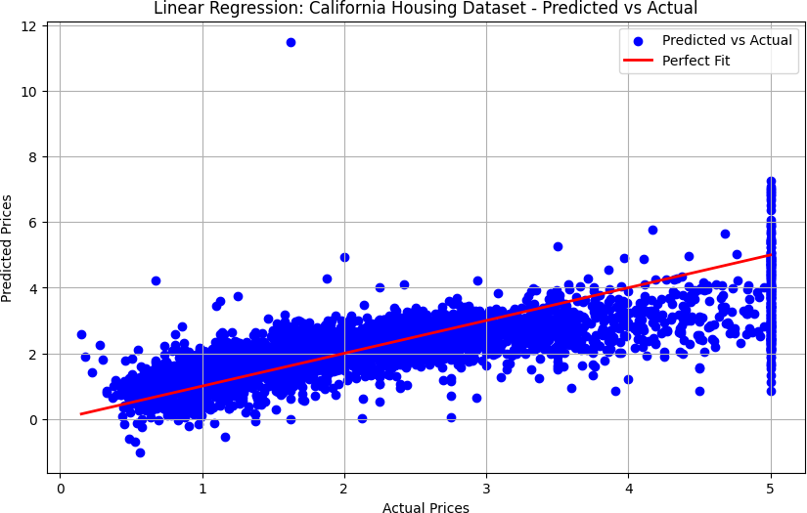
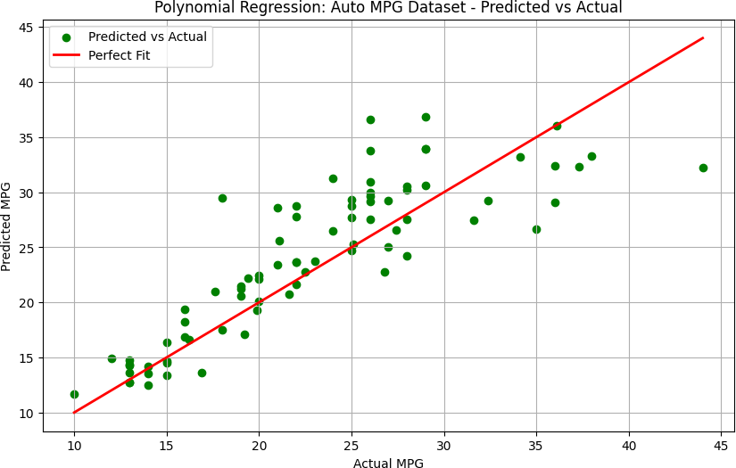

- Develop a program to demonstrate the working of the decision tree algorithm. Use Breast Cancer Data set for building the decision tree and apply this knowledge to classify a new sample.

import numpy as np import pandas as pd
from sklearn.datasets import load_breast_cancer from sklearn.model_selection import train_test_split from sklearn.tree import DecisionTreeClassifier from sklearn.metrics import accuracy_score
from sklearn import tree import matplotlib.pyplot as plt

# Step 1: Load the Breast Cancer dataset data = load_breast_cancer()
X = data.data # Features
y = data.target # Labels (0 for malignant, 1 for benign)

# Step 2: Split the data into training and testing sets
X_train, X_test, y_train, y_test = train_test_split(X, y, test_size=0.2, random_state=42)

# Step 3: Train the Decision Tree classifier clf = DecisionTreeClassifier(random_state=42) clf.fit(X_train, y_train)

# Step 4: Make predictions and evaluate the model y_pred = clf.predict(X_test)

# Evaluate the model's accuracy
accuracy = accuracy_score(y_test, y_pred)
print(f"Accuracy of the Decision Tree classifier: {accuracy:.4f}")

# Step 5: Classify a new sample
# Example of a new sample (random values taken from the dataset) new_sample = np.array([[
13.49, # mean radius 14.59, # mean texture 85.53, # mean perimeter 576.3, # mean area 0.09744, # mean smoothness 0.05714, # mean compactness 0.07278, # mean concavity
0.03935, # mean concave points 0.00311, # mean symmetry 0.02904, # mean fractal dimension 15.65, # radius error
22.89, # texture error 94.77, # perimeter error 636.2, # area error 0.01617, # smoothness error
0.03077, # compactness error 0.01052, # concavity error 0.01367, # concave points error 0.00124, # symmetry error
0.00398, # fractal dimension error 22.55, # worst radius
31.77, # worst texture

141.7, # worst perimeter 1133, # worst area 0.1622, # worst smoothness
0.3013, # worst compactness 0.4613, # worst concavity 0.2217, # worst concave points 0.01139, # worst symmetry
0.05796 # worst fractal dimension
]])

# Predict the class of the new sample new_pred = clf.predict(new_sample)
print(f"The prediction for the new sample is: {'Benign' if new_pred == 1 else 'Malignant'}")

# Step 6: Visualize the Decision Tree plt.figure(figsize=(12, 8))
tree.plot_tree(clf, filled=True, feature_names=data.feature_names, class_names=data.target_names, rounded=True)
plt.title("Decision Tree for Breast Cancer Classification")
plt.show()

Output :
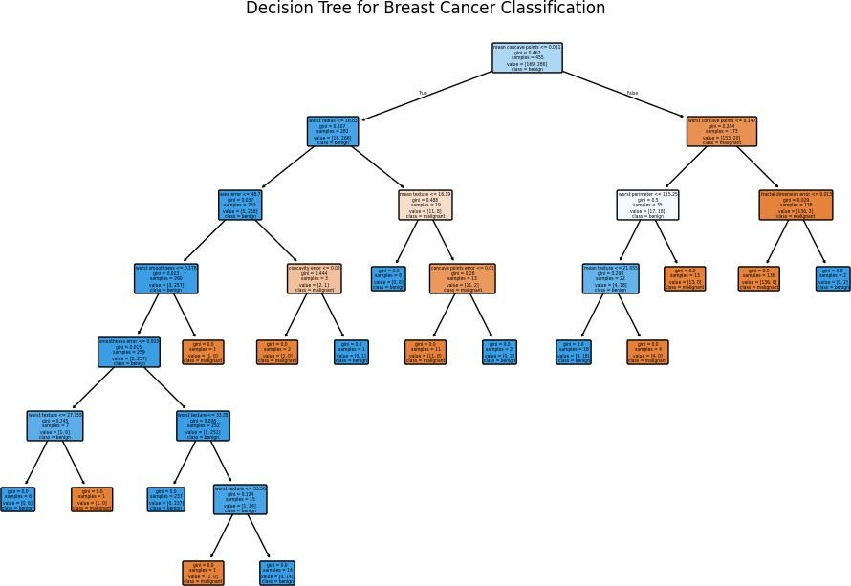
Accuracy of the Decision Tree classifier: 0.9474 The prediction for the new sample is: Benign

- Develop a program to implement the Naive Bayesian classifier considering Olivetti Face Data set for training. Compute the accuracy of the classifier, considering a few test data sets.

import numpy as np
from sklearn.datasets import fetch_olivetti_faces from sklearn.model_selection import train_test_split from sklearn.naive_bayes import GaussianNB
from sklearn.metrics import accuracy_score import matplotlib.pyplot as plt

# Step 1: Load the Olivetti Face dataset
faces_data = fetch_olivetti_faces(shuffle=True, random_state=42)
X = faces_data.data # Features (each face is represented as a flattened 64x64 image)
y = faces_data.target # Labels (each image has a label representing the person)

# Step 2: Split the data into training and testing sets
X_train, X_test, y_train, y_test = train_test_split(X, y, test_size=0.25, random_state=42)

# Step 3: Train a Naive Bayes classifier (Gaussian Naive Bayes) nb_classifier = GaussianNB()
nb_classifier.fit(X_train, y_train)

# Step 4: Make predictions on the test set y_pred = nb_classifier.predict(X_test)

# Step 5: Evaluate the accuracy of the classifier accuracy = accuracy_score(y_test, y_pred)
print(f"Accuracy of the Naive Bayes classifier: {accuracy:.4f}")

# Step 6: Visualize some test samples and their predictions fig, axes = plt.subplots(2, 5, figsize=(10, 5))
for i, ax in enumerate(axes.flat): ax.imshow(X_test[i].reshape(64, 64), cmap='gray') ax.set_title(f"Pred: {y_pred[i]}")
ax.axis('off') plt.tight_layout() plt.show()

Output :
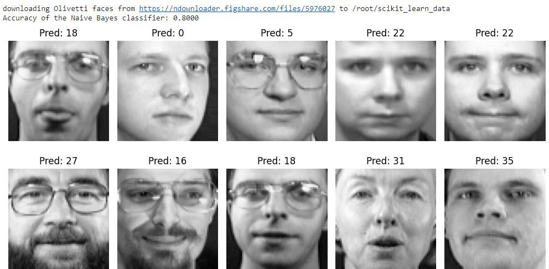

- Develop a program to implement k-means clustering using Wisconsin Breast Cancer data set and visualize the clustering result.
import numpy as np import pandas as pd
import matplotlib.pyplot as plt
from sklearn.datasets import load_breast_cancer from sklearn.decomposition import PCA
from sklearn.cluster import KMeans

# Step 1: Load the Wisconsin Breast Cancer dataset data = load_breast_cancer()
X = data.data # Features
y = data.target # Labels (0 for malignant, 1 for benign)

# Step 2: Apply PCA for dimensionality reduction (from 30 features to 2 for visualization)
pca = PCA(n_components=2) X_pca = pca.fit_transform(X)

# Step 3: Perform K-means clustering
kmeans = KMeans(n_clusters=2, random_state=42) # 2 clusters, since there are 2 classes: malignant and benign
kmeans.fit(X_pca)

# Step 4: Visualize the clustering results plt.figure(figsize=(8, 6))
plt.scatter(X_pca[:, 0], X_pca[:, 1], c=kmeans.labels_, cmap='viridis', marker='o', s=100, edgecolor='k')
plt.title("K-means Clustering on Breast Cancer Data (PCA Reduced)") plt.xlabel("Principal Component 1")
plt.ylabel("Principal Component 2")

# Show cluster centers
centers = kmeans.cluster_centers_
plt.scatter(centers[:, 0], centers[:, 1], s=200, c='red', marker='x', label='Centroids')

# Add a legend plt.legend() plt.grid(True)
plt.show()
Output :
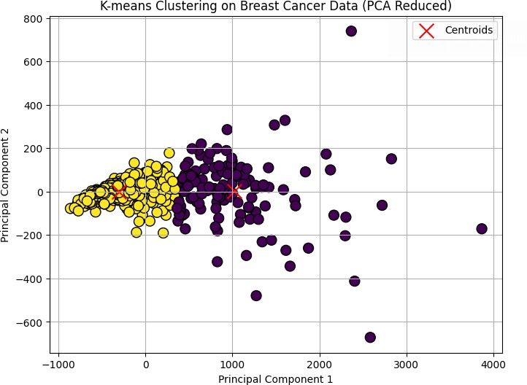

VIVA VOCE
- Which library is primarily used for creating visualizations in Python?
  - NumPy
  - pandas

Matplotlib
  - scikit-learn

- What type of plot is suitable for identifying outliers in a dataset?
  - Histogram
  - Scatter plot

Box plot
  - Pair plot

- What does a correlation matrix represent?
  - The distribution of individual features

The pairwise relationships between features
  - The outliers in the dataset
  - The missing values in the dataset

- What is the purpose of a heatmap in the context of a correlation matrix?
  - To display the distribution of each feature

To visualize the strength and direction of correlations
  - To identify outliers
  - To perform dimensionality reduction

- Which scikit-learn class is used for Principal Component Analysis (PCA)?
  - `LinearRegression` c) `KMeans`
  - `PCA` d ) `DecisionTreeClassifier`

- What is the primary goal of PCA?
  - To improve model accuracy

To reduce the number of features while preserving variance
  - To identify outliers
  - To create visualizations

- What preprocessing step is often applied before PCA?
  - Normalization

Standardization
  - One-hot encoding
  - Imputation

- In the k-Nearest Neighbors (KNN) algorithm, what does 'k' represent?
  - The number of features
  - The number of classes

The number of nearest neighbors to consider
  - The learning rate

- What is the main purpose of the KNN algorithm?
  - Regression

Classification
  - Clustering
  - Dimensionality reduction

- What is the key idea behind Locally Weighted Regression (LWR)?
  - To give equal weight to all data points

To weight nearby points more heavily than distant points
  - To perform linear regression on the entire dataset
  - To identify outliers

- What is the role of the bandwidth parameter (tau) in LWR?
  - It determines the learning rate

It controls the width of the weighting kernel
  - It specifies the number of neighbors
  - It sets the regularization strength

- Which algorithm builds a tree-like structure to make decisions?
  - Linear Regression
  - K-means

Decision Tree
  - PCA

- What is the purpose of splitting a dataset into training and testing sets?
  - To increase the size of the dataset

To evaluate the model's performance on unseen data
  - To reduce the number of features
  - To identify outliers

- What metric is commonly used to evaluate the performance of a classification model?
  - Mean Squared Error

Accuracy
  - R-squared
  - Variance

- Which of the following is a probabilistic classifier?
  - K-means
  - Decision Tree

Naive Bayes
  - KNN

- What assumption does the Naive Bayes classifier make about features?
  - Features are linearly correlated
  - Features are normally distributed

Features are independent
  - Features are categorical

- What type of data is the Olivetti Faces dataset typically used for?
  - Regression

Image classification
  - Text classification
  - Time series analysis

- What is the goal of k-means clustering?
  - To predict class labels

To group similar data points into clusters
  - To reduce the number of features
  - To identify outliers

- In k-means, what do the cluster centers represent?
  - The most common data point in the cluster

The average of all data points in the cluster
  - The outliers in the cluster
  - Randomly chosen points

- What is a common technique used to reduce the dimensionality of data before applying k-means clustering, especially for visualization purposes?
  - Normalization
  - Standardization

Principal Component Analysis (PCA)
  - One-Hot Encoding

